Testing table V3
Changes made: Added constants, rounded to 0 dp, checking for inputs that aren’t numbers and for inputs that have decimals.
Input | Expected output | Actual output | Passed?
17, 61, 51, 28, 76 – Valid results | Average score: 54%  Smallest score: 20%  Largest score: 87%  Total amount of scores: 5  Scores, sorted smallest to largest:  20%  32%  59%  70%  87% | 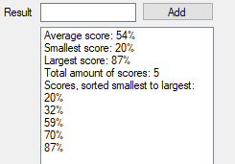 | Y
88 – Out of range | Please input a valid whole number in the range 0 to 87 inclusive! Message box. | 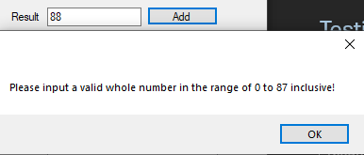 | Y
-1 – Out of range | Please input a valid whole number in the range 0 to 87 inclusive! Message box. | 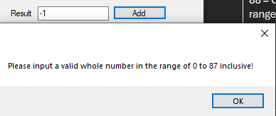 | Y
Ten – Invalid data | Please input a valid whole number in the range 0 to 87 inclusive! Message box. | 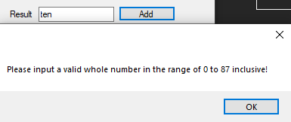 | Y
Show results pressed with no data | No results to show! Message box. | 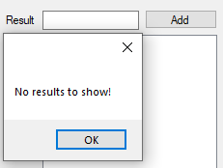 | Y
87 – Highest acceptable number | Accepted. | Number is accepted by program. | Y
20.5 – Non int score | Please enter a whole number between 0 and 87 inclusive! | 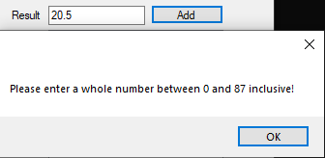 | Y
0 – Lowest acceptable number | Accepted. | Number is accepted by program. | Y
23, 52, 70, 9, 80 – Second valid results dataset | Average score: 54%  Smallest score: 10%  Largest score: 92%  Total amount of scores: 5  Scores, sorted smallest to largest:  10%  26%  60%  80%  92% | 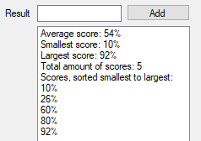 | Y

